User Manual

# Web Application

To use our web application, go to <http://18.184.207.248/>, the first page you encounter is the login page, If you are a registered user sign in with your username and password that you specify during the sign up process. 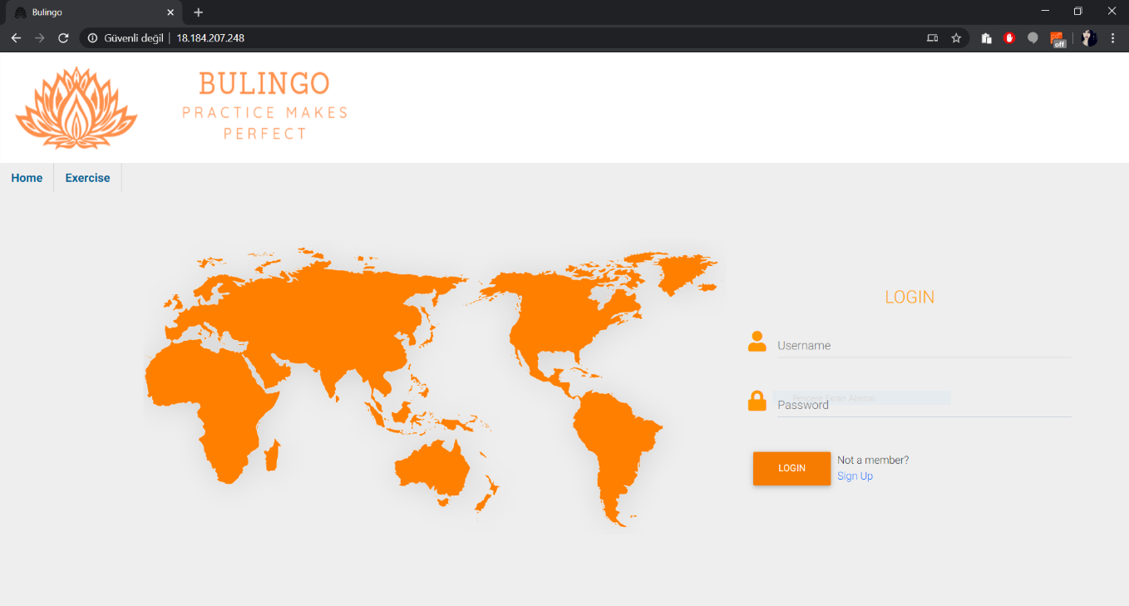

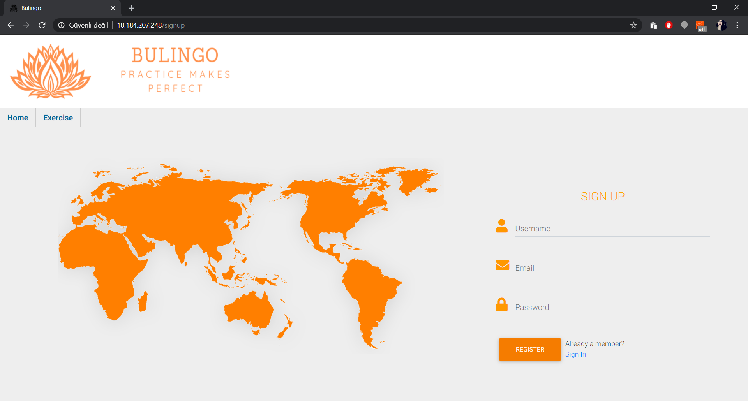If you are a guest user you can go to Sign Up page by clicking the blue Sign Up label next to the LOGIN button or see a list of the exercises as a guest by clicking the Exercise button on the navigation bar.

In the exercises page for a guest user first you can select the language and the see a list of all exercises for that language, to access these exercises you must create an account. 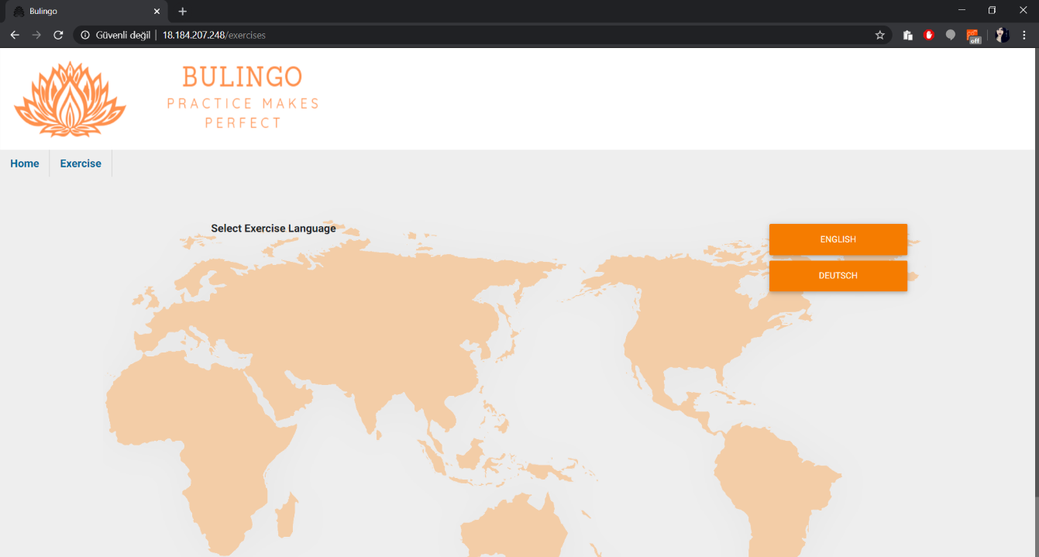

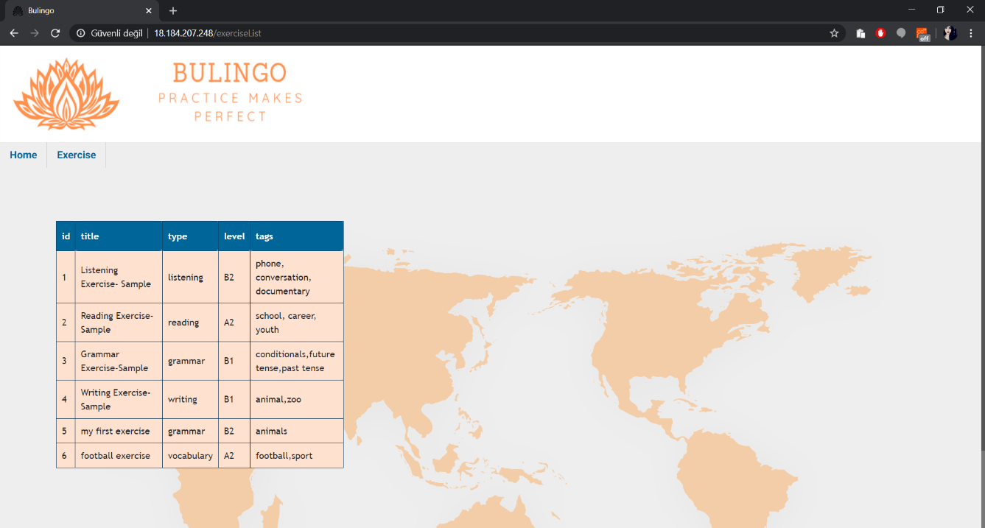

After you register and log in, you can see your profile page. From the profile page most of the functionalities of the application are available. From the profile page you can see your language progress in the radar chart (right side of the page), the comments done to you (middle section) and your profile picture and biography (right side of the page). From the navigation bar you can access to exercises(only the exercises in your level is accessible here), send exercise page to create and submit your own exercises, exam page to take level determination exam, my writing page to see and annotate the writings you sent to other people and the writings other people sent to you, messages page to see you personal messages, search page that you can search exercises related to a keyword or users, and the settings page where you can customize your biography.

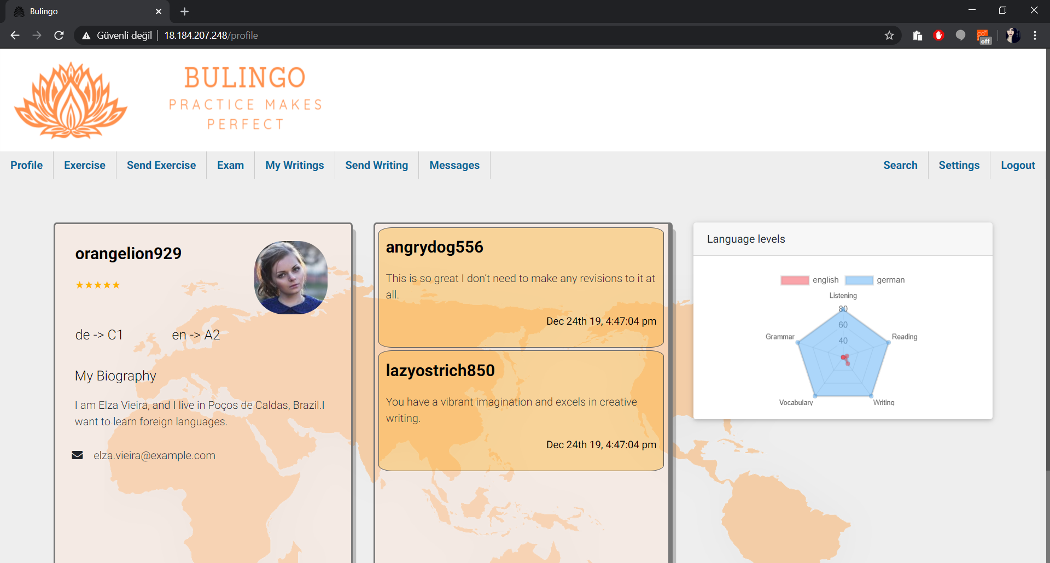

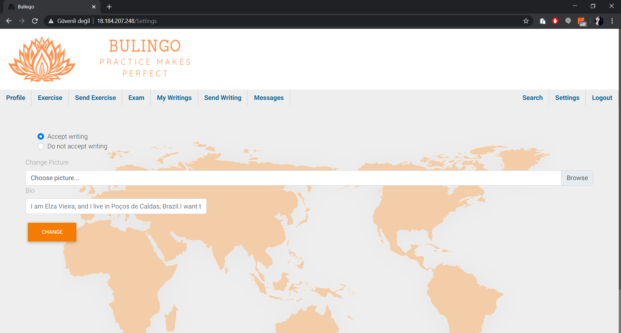Let’s start with settings, In the settings page you can change your biography, profile picture and specify your preferences about accepting the writings from other users or not. By clicking the CHANGE button, you can submit your changes.

The next page is the exam page, firstly you must choose the language of the level determination test with a similar process to choose exercise language selection stated above. After the selection there are multiple choice questions, and after choosing the correct answer for all the questions you should click to the submit button for evaluation. Your score will appear on the top of the page.

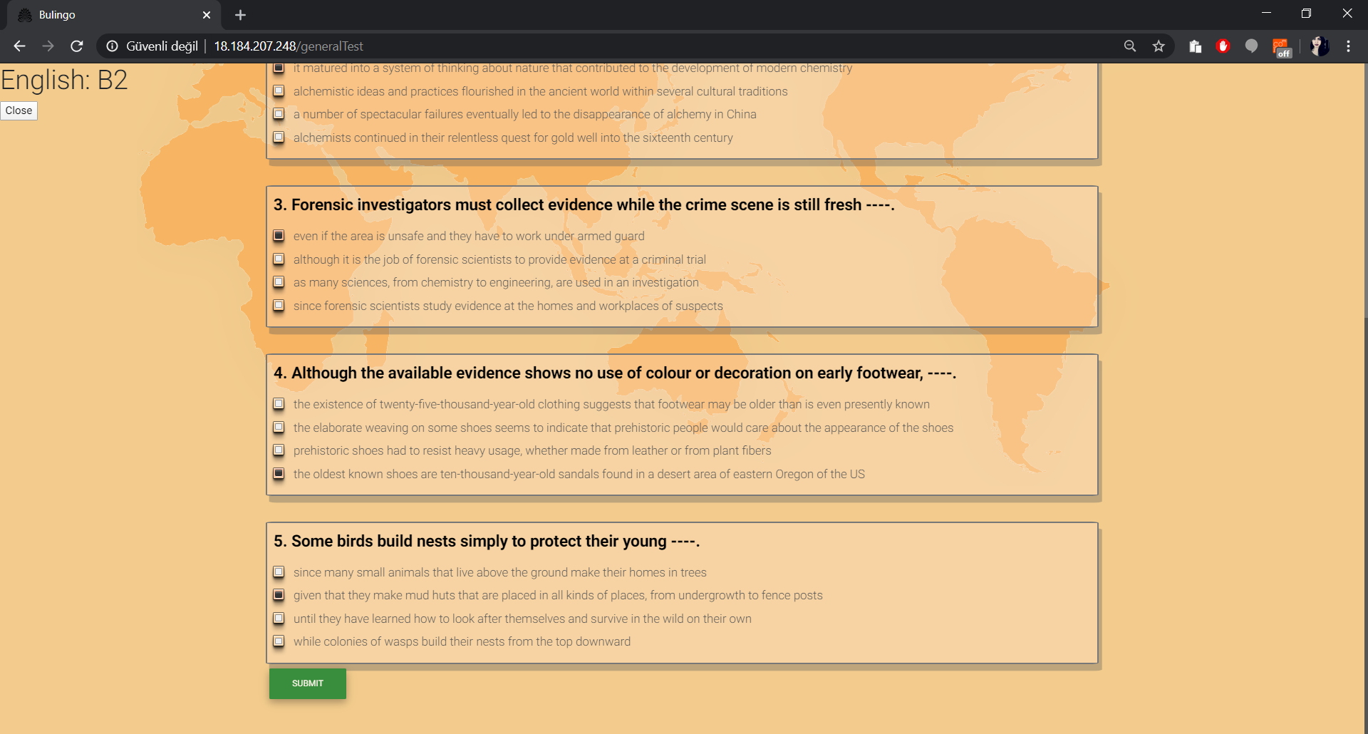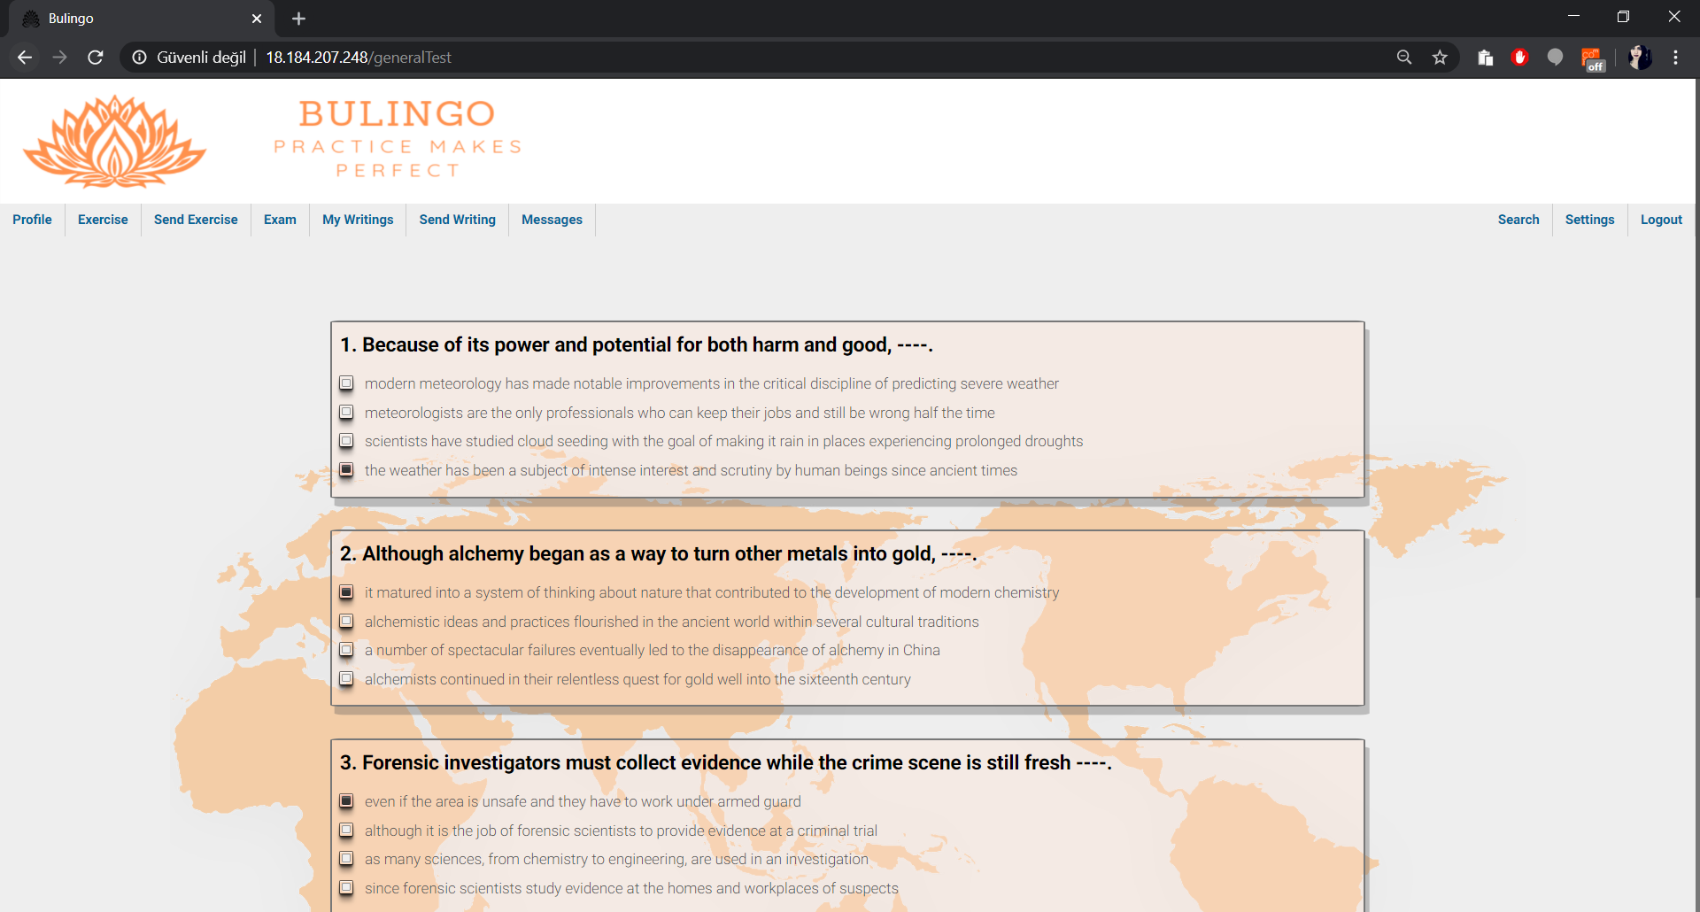

After completing the level determination exam, you can see the exercises in your own level and work on your skills. To do so click on the exercises in the navigation bar and select the language you want to proceed. In the list of the available exercises you can click on the exercise title to go to exercise. Completing the exercise is like the level determination exam but now you can see the correct answers after completing and submitting. 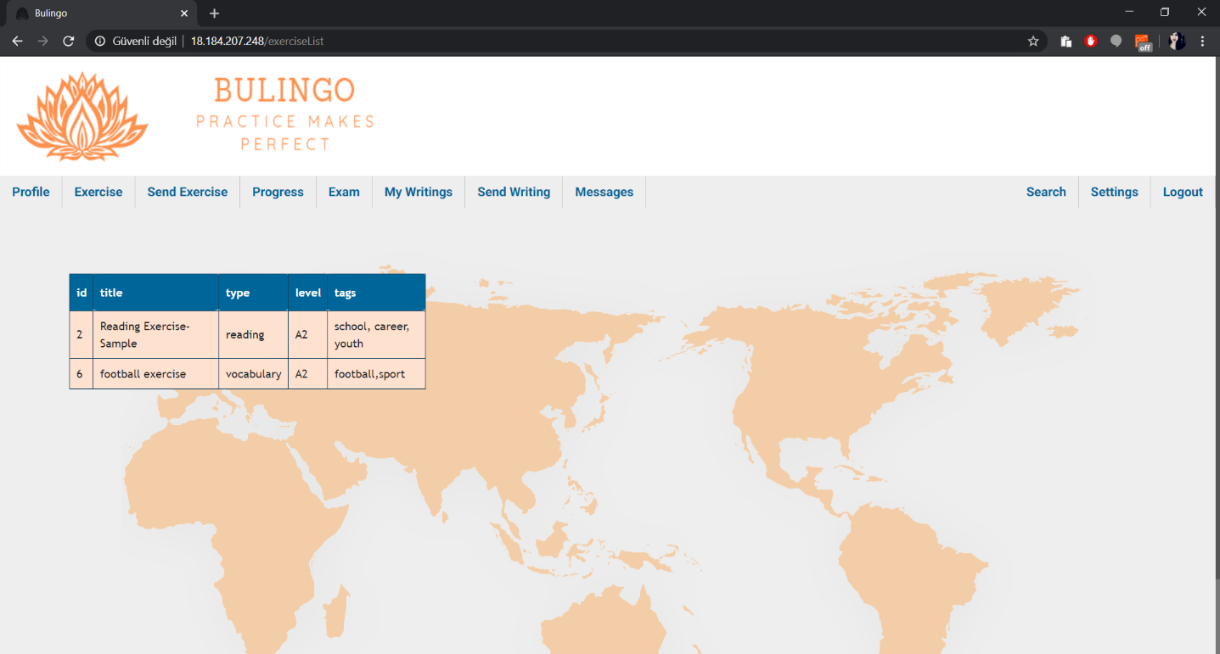

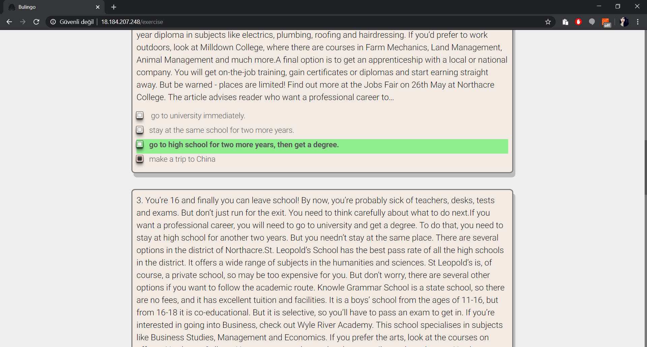

You can send exercises from send exercises page, here you should specify title, tags, language, level and exercise type of the exercise you are going to add. After that you should fill the body parts and the choices, pick the true answer from the choices and submit after compeleting all the questions and answers.

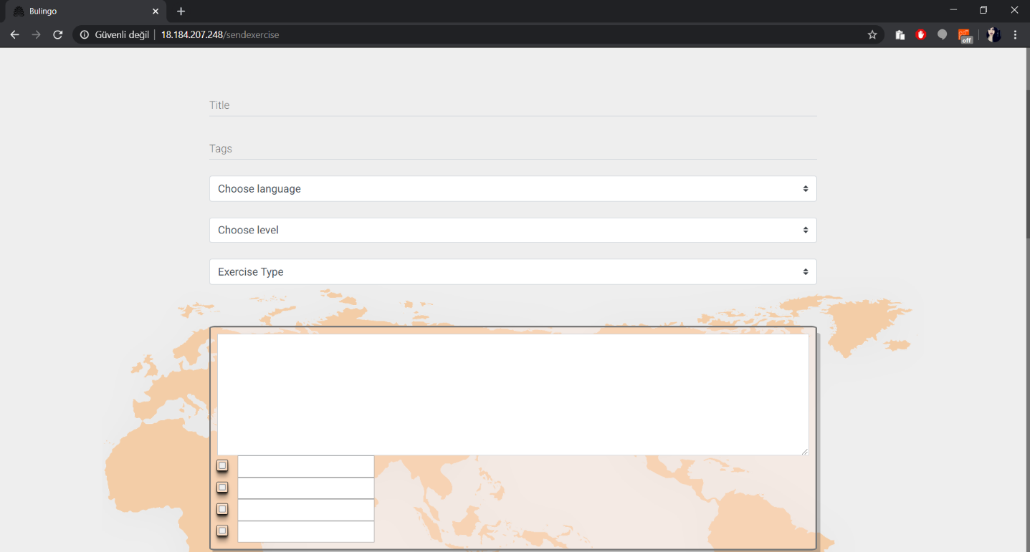

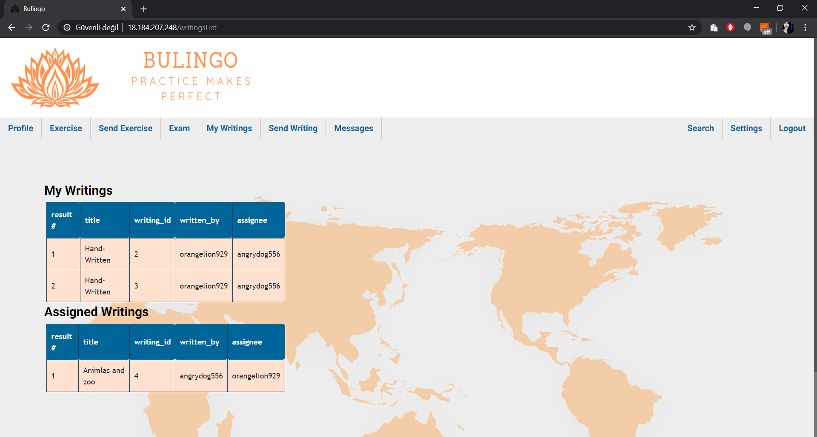 In my writings page you can see the writings you sent, and the writings assigned to you. To go to the writing, click on the title.

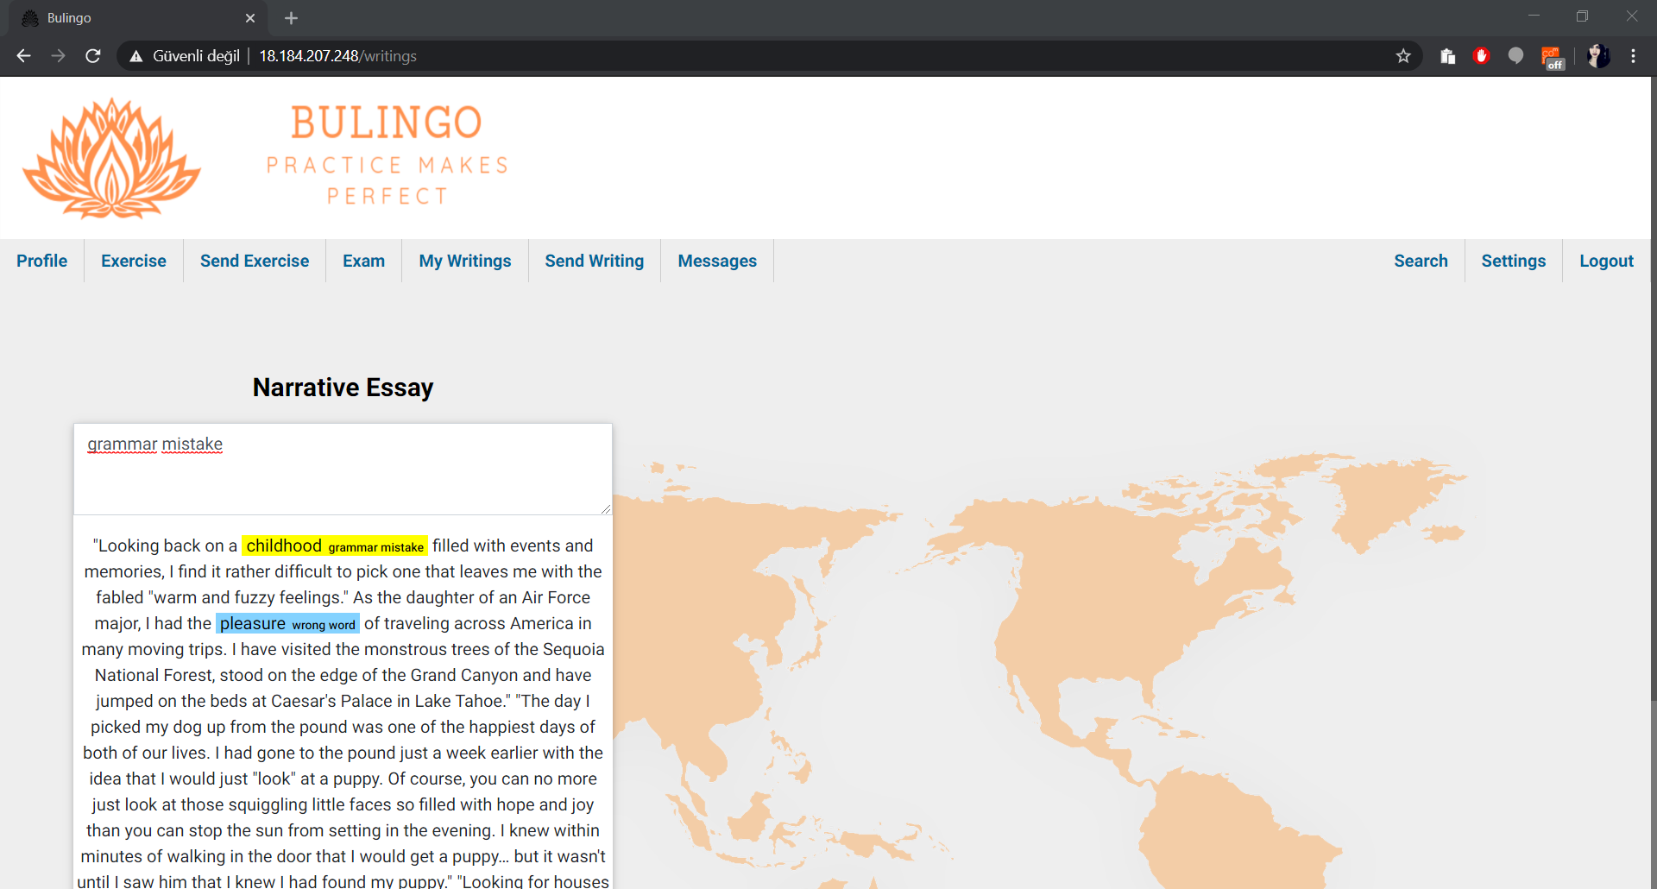After going in the writing page you can read and annotate the writing, to annotate a text you can write your annotation to the text box and select the text you want to annotate. You can delete the yellow annotations by clicking on them once. After editing, send you annotations by pressing submit.

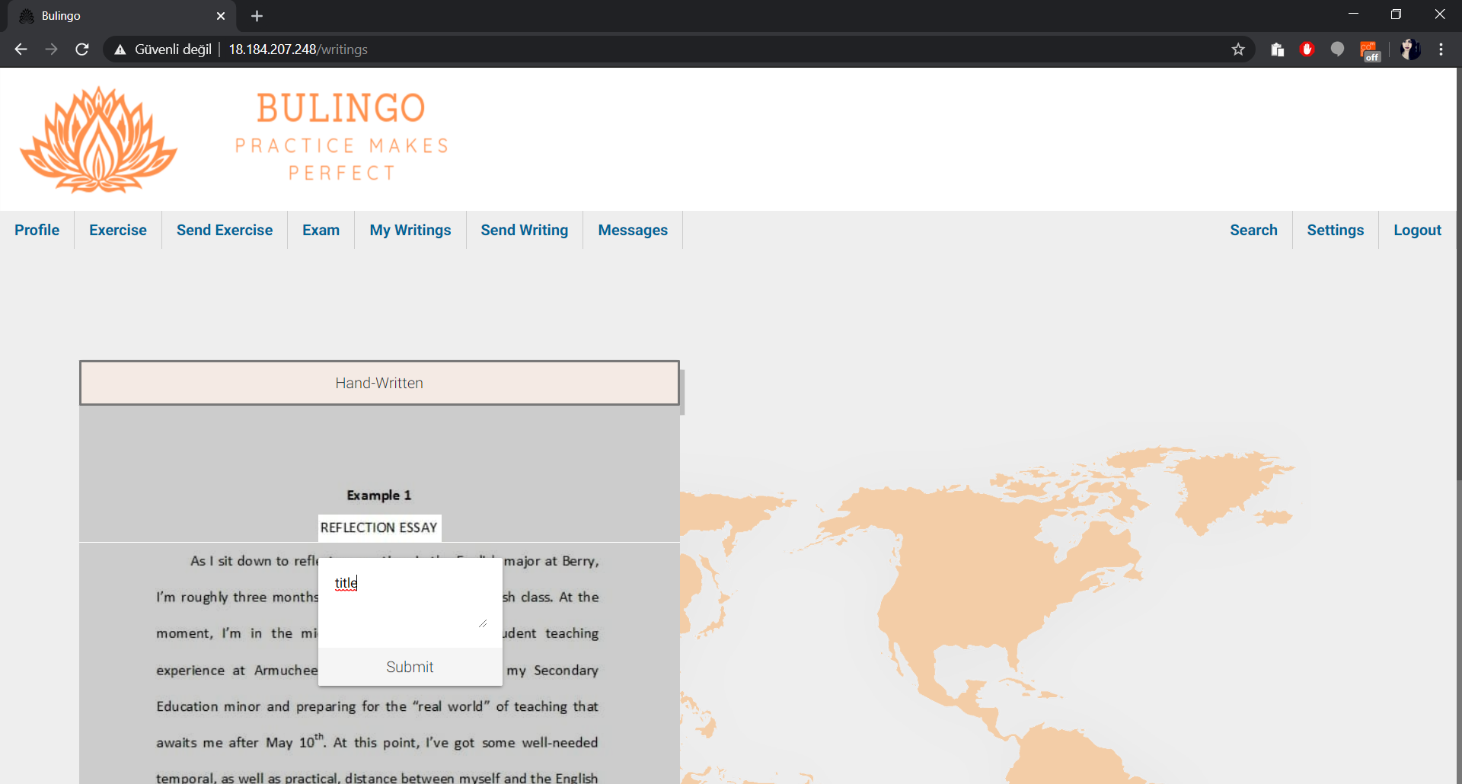To annotate an image, click and drag until the box covers the area you want to annotate. Release the mouse and write you annotation to the textbox. When you are ready, submit by clicking on the submit button. You can see the existing annotation by clicking on them.

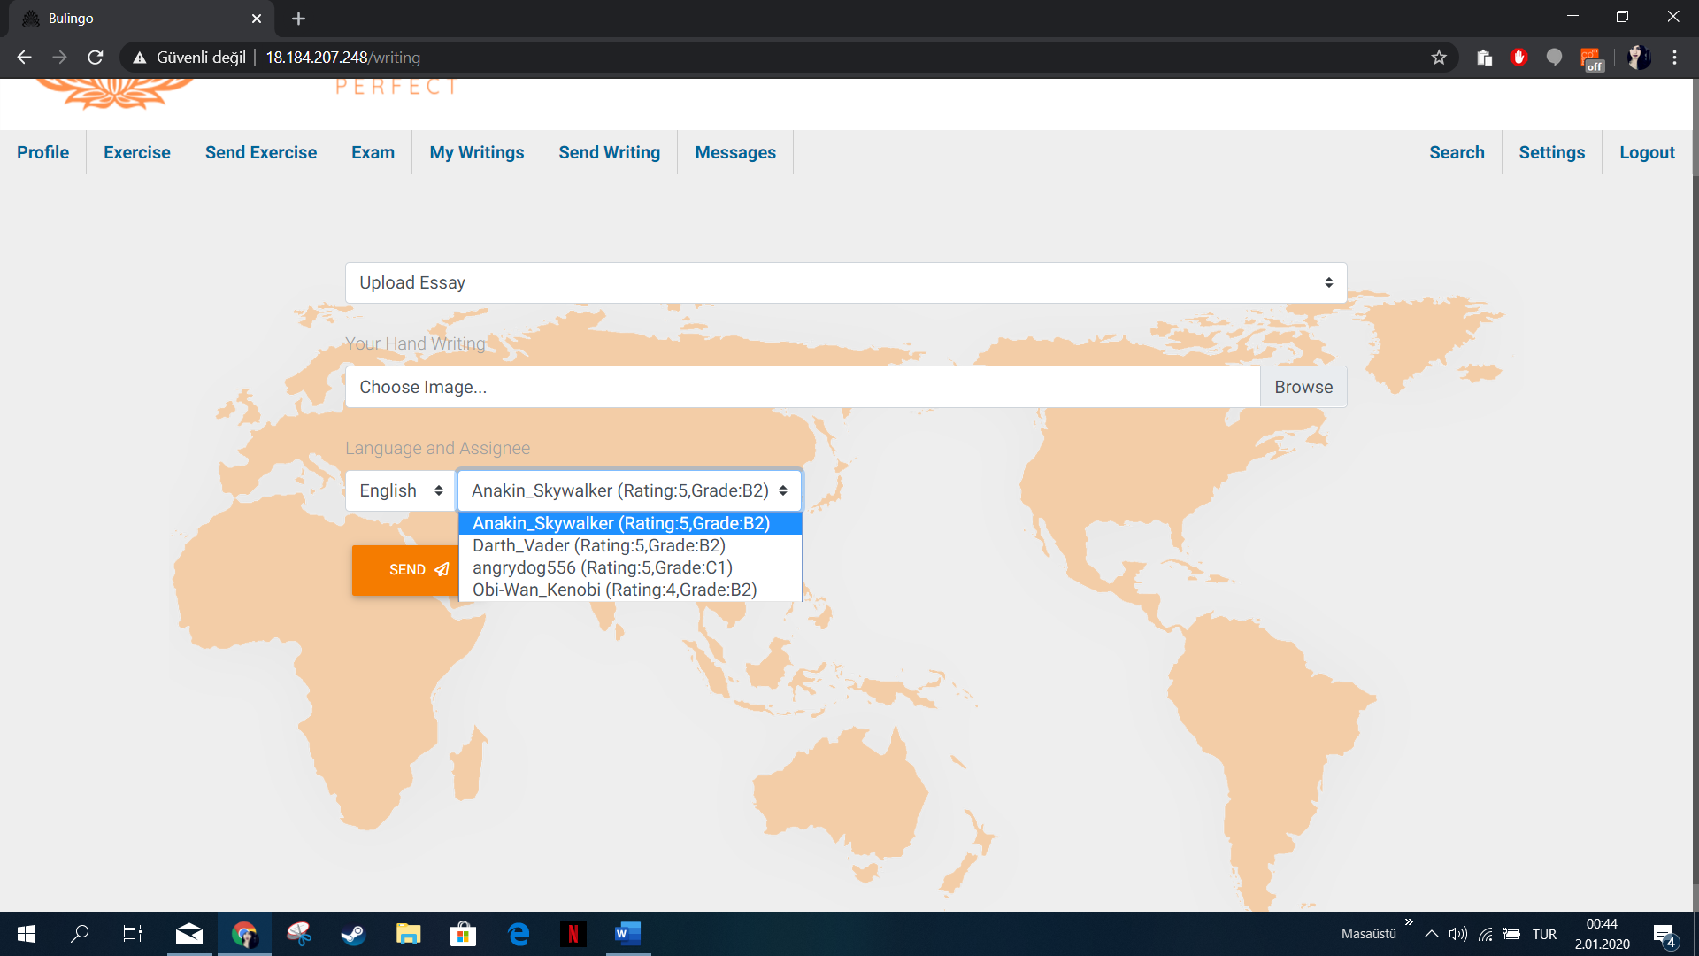To send writing, you can write you essay in the textbox, if you would like to upload a file, you should select upload essay option from the drop-down menu. After you select the language, the recommended users will appear and you can select by looking at their rating and language level.

To see and answer your messages go to messages page from navbar in the left you can see the list of the people you are chatting with and by clicking on the boxes on the left you can see the message history and send a message on the right

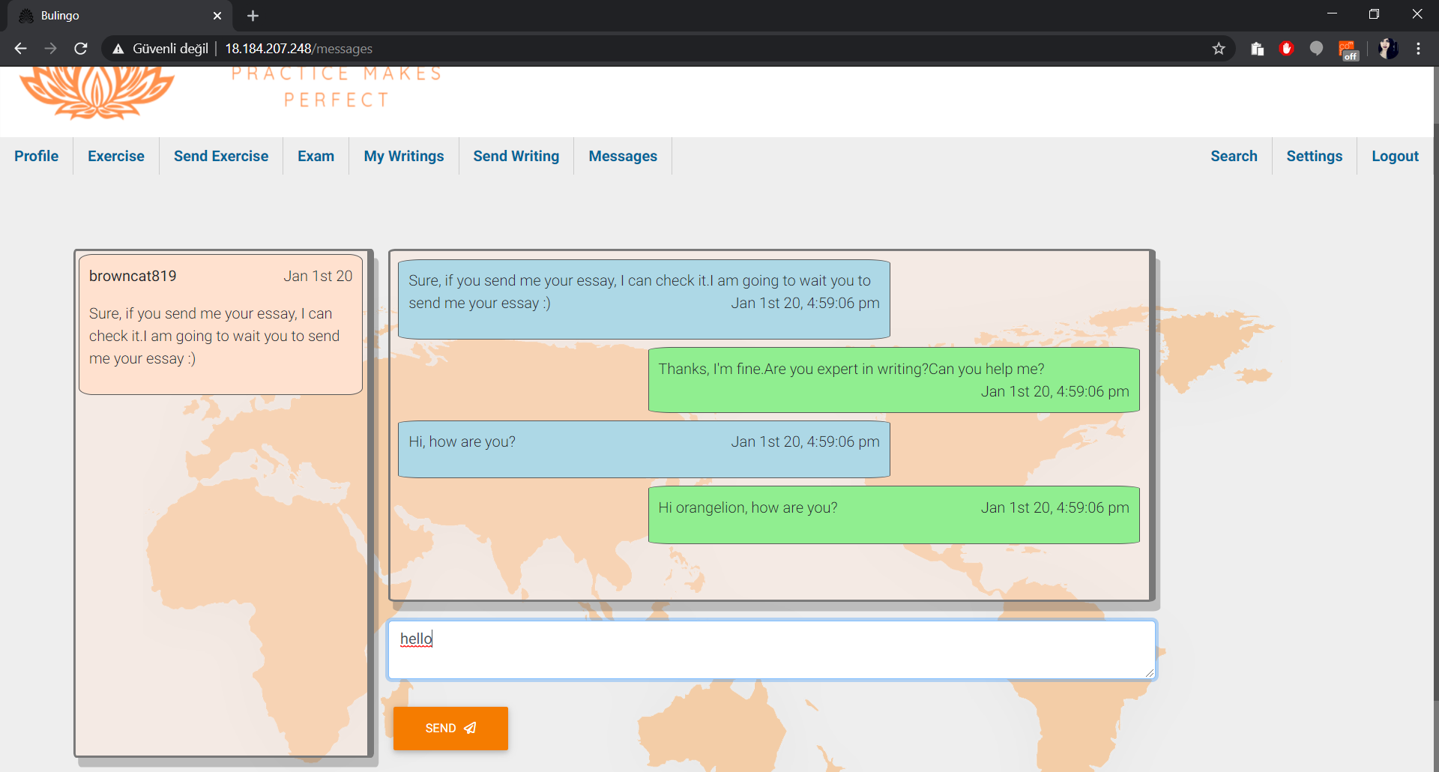

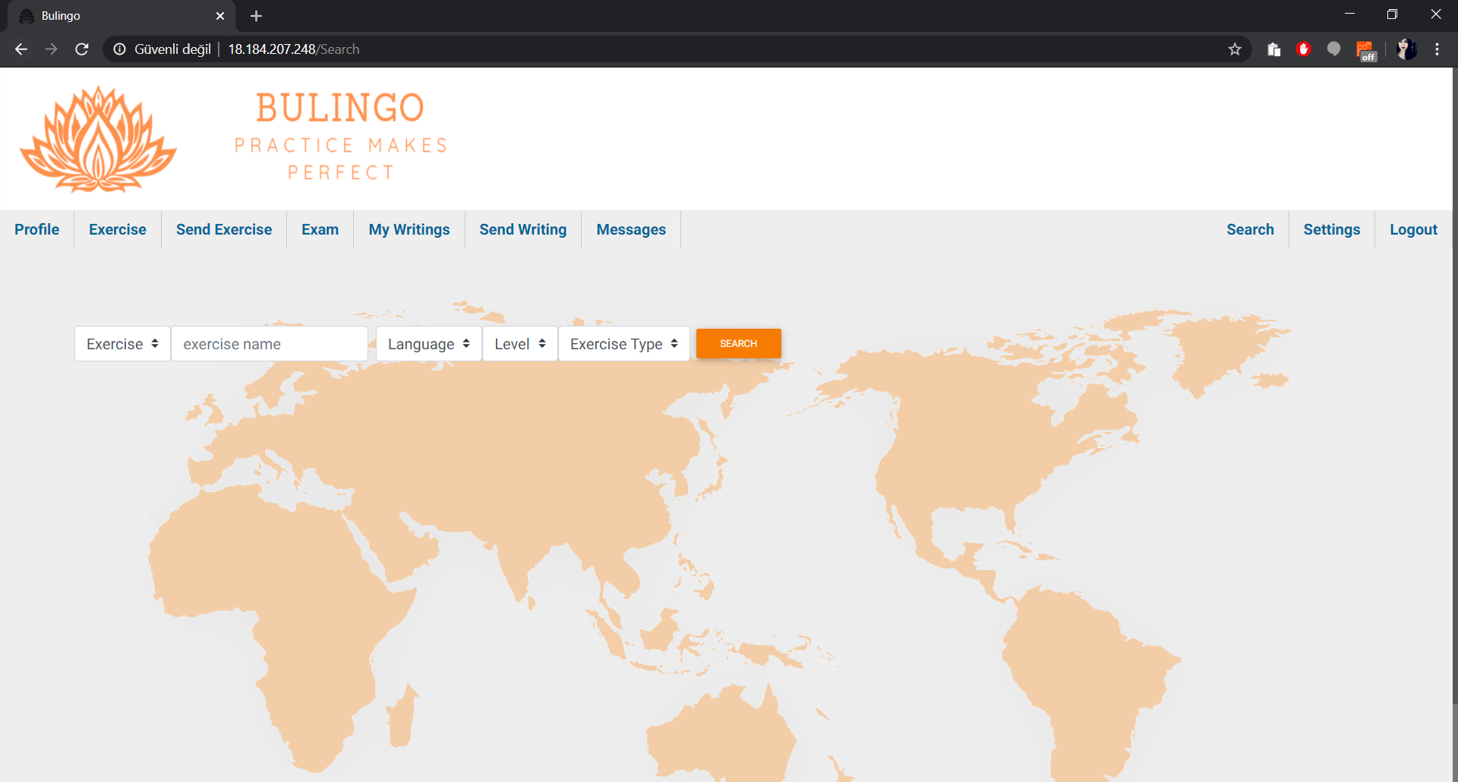To search a user or an exercise click on the search button on the navigation bar. First select if you want to search a user or exercise, then write your keyword for the search. For exercise you can further specify language, language level, and exercise type. Click on the search button to search to proceed.

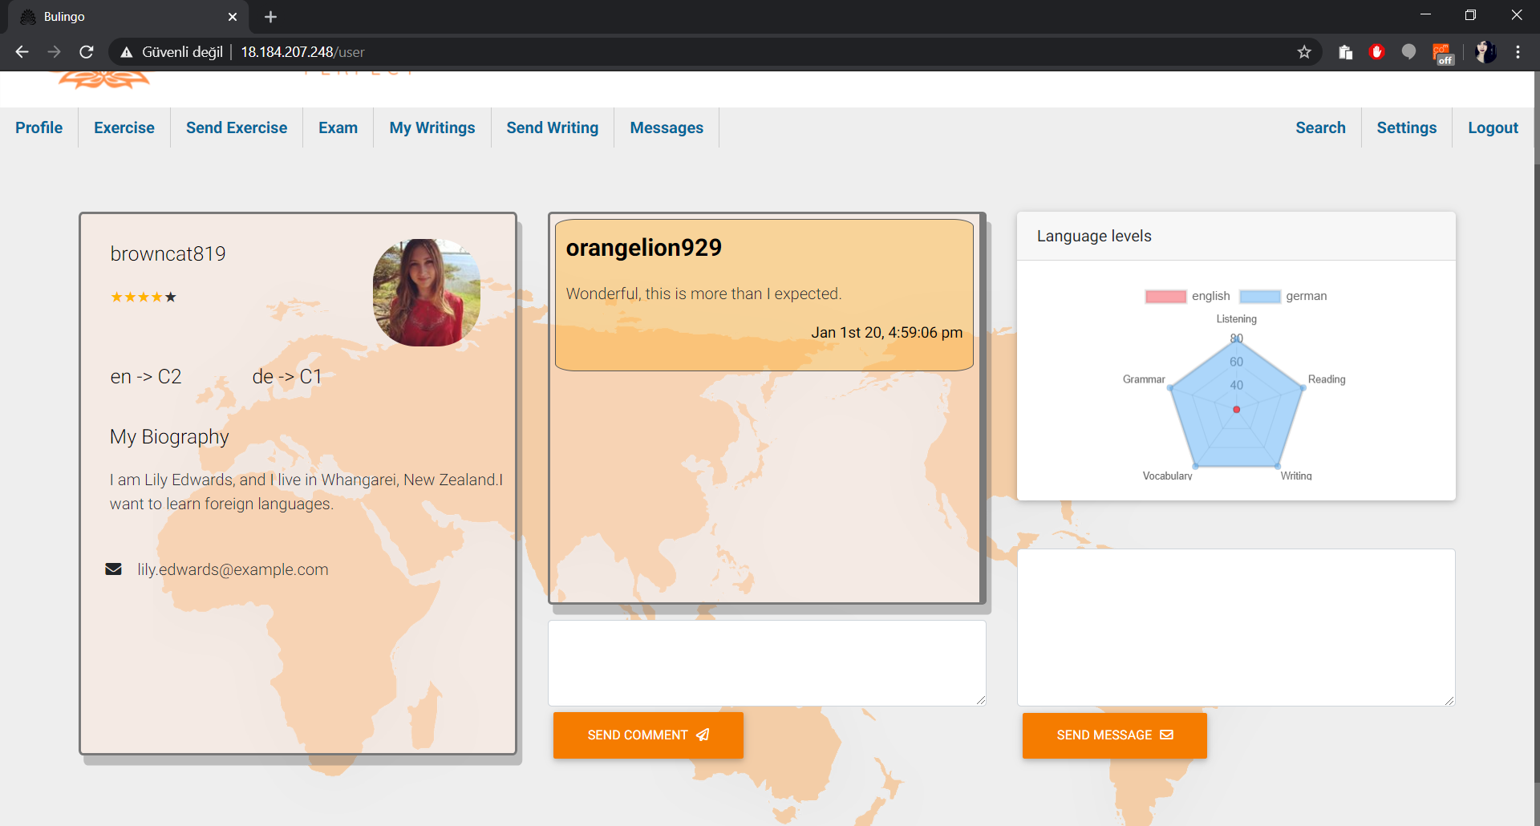To make a comment and rate a user you should search them from user search and by clicking on the username from a list of users you can go to their profile. Here you can make a comment and rate the user and send a message. After sending a message you get redirected to the messages page.